SE assignment

What is software? What is software engineering?

Software engineering has two parts: software and engineering. Software is a collection of codes, documents, and triggers that does a specific job and fills a specific requirement. Engineering is the development of products using best practices, principles, and methods.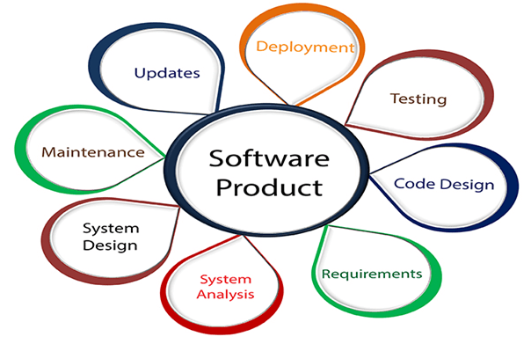

Explain types of software

The two main categories of software are application software and system software. An application is software that fulfills a specific need or performs tasks.

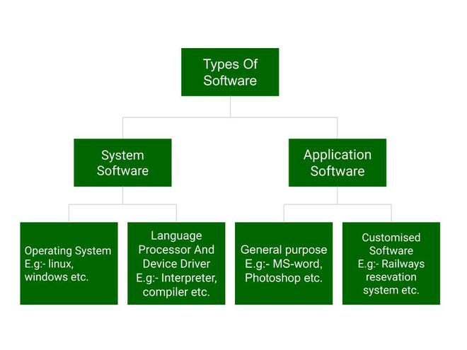

What is SDLC? Explain each phase of SDLC

An SDLC (software development life cycle) is a big-picture breakdown of all the steps involved in software creation (planning, coding, testing, deploying, etc.). Companies define custom SDLCs to create a predictable, iterative framework that guides the team through all major stages of development.

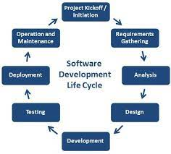

What is DFD? Create a DFD diagram on Flipkart

Data flow diagram (DFD) is a diagram being used frequently in software design. It visually represents the flow of data throughout processes in a given system. DFD shows the kind of information that will be input to and output from processes as well as where the data will be stored.

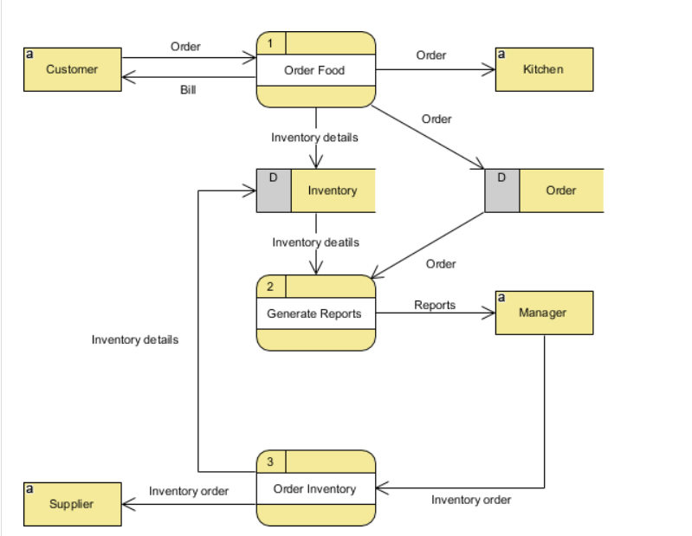

**What is Flow chart? Create a flowchart to make addition of two numbers**

A flowchart is a type of diagram that represents a workflow or process. A flowchart can also be defined as a diagrammatic representation of an algorithm, a step-by-step approach to solving a task. The flowchart shows the steps as boxes of various kinds, and their order by connecting the boxes with arrows.

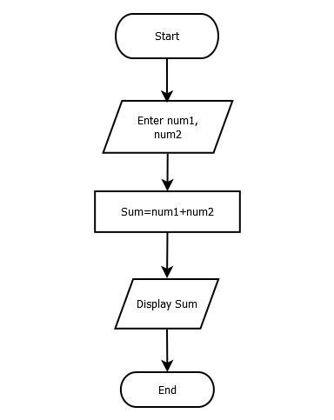

**What is Use case Diagram? Create a use-case on bill payment on paytm.**

A use case diagram is a graphical depiction of a user's possible interactions with a system. A use case diagram shows various use cases and different types of users the system has and will often be accompanied by other types of diagrams as well. The use cases are represented by either circles or ellipses.

